1 create dockefile and python file

2 docker file

3 py fi

4 create docker image
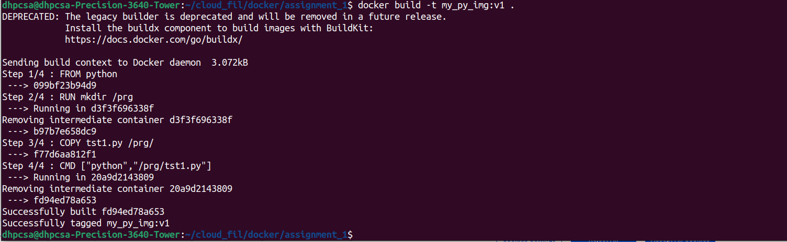

5 check images
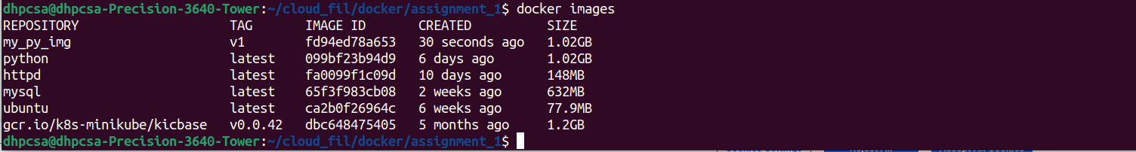

6 run the container

7 push docker image to docker hub
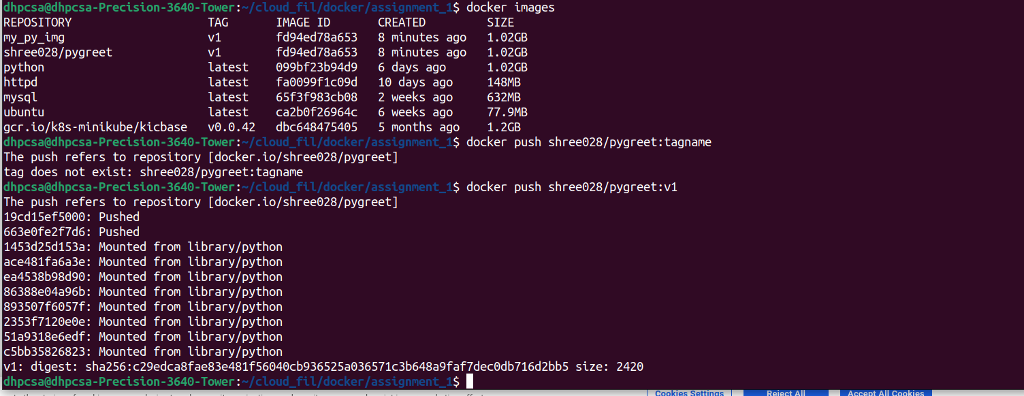

8 image on docker hub
